**LAB QUESTION 5**

QUE 1:- Write a Java program that reads a string from the user and uses StringTokenizer to split the string into individual words. Print each word on a new line.

INPUT:-

package String;

import java.util.StringTokenizer;

import java.util.Scanner;

public class StringSplitter {

public static void main(String[] args) {

// TODO Auto-generated method stub

//initializing the scanner

Scanner sc=new Scanner(System.in);

//getting input from user

System.out.println("Enter the String");

String name = sc.nextLine();

//creating object of the StringTokenizer

StringTokenizer st=new StringTokenizer(name);

//condition for splitting the string into a individual words

while(st.hasMoreTokens()) {

System.out.println(st.nextToken());

}

sc.close();

}

}

OUTPUT:-

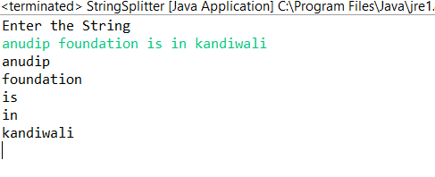

QUE 2:- Write a Java program that reads a string from the user and uses StringTokenizer to count the number of words in the string.

INPUT:-

package String;

import java.util.Scanner;

import java.util.StringTokenizer;

public class StringCount

{

public static void main(String[] args)

{

// TODO Auto-generated method stub

//initializing the scanner

Scanner sc=new Scanner(System.in);

//getting output from the user

System.out.println("Enter the string: ");

String string=sc.nextLine();

//creating the object of the StringTokenizer

StringTokenizer s=new StringTokenizer(string);

//code for counting the words

int wordCount=0;

while(s.hasMoreTokens())

{

s.nextToken();

wordCount++;

}

System.out.println("the word count is: "+wordCount);

sc.close();

}

}

OUTPUT:-

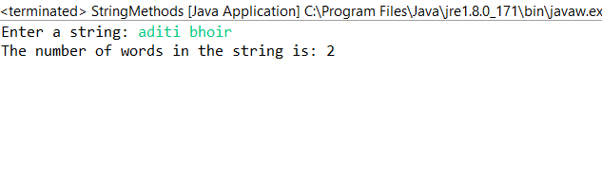

QUE 3:-Write a java program to create a LinkedList of string, add elements at specific position (beginning,middle,end) and print the list.

INPUT:-

**package Collection;**

**import java.util.*;**

**public class LinkedListAddtingElement {**

**public static void main(String[] args) {**

**// TODO Auto-generated method stub**

**//creating the object of linked list**

**LinkedList<String>a=new LinkedList<String>();**

**//adding the elements in the linked list**

**a.add("pen");**

**a.add("pencil");**

**a.add("eraser");**

**//printing the linked list**

**System.*out*.println("printing the LinkedList: "+a);**

**//adding element in the middle of linked list**

**a.add(0,"notebook");**

**System.*out*.println("printing the elements in the middel of LinkedList: "+a);**

**//adding elements in the beginning of the linked list**

**a.addFirst("book");**

**System.*out*.println("printing the elements in beginning of the LinkedList: "+a);**

**//adding the elements in ending of linked list**

**a.addLast("ruler");**

**System.*out*.println("printing the elements in ending of the LinkedList: "+a);**

**}**

**}**

OUTPUT:-

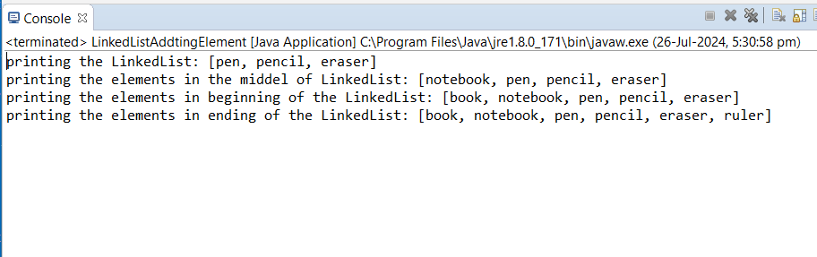

QUE 4:-Write a Java program to sort a given array list.

INPUT:-

**package** Array;

**import** java.util.ArrayList;

**import** java.util.Collections;

**public** **class** SortingArray {

**public** **static** **void** main(String[] args) {

// Create an ArrayList and add some integers

ArrayList<Integer> numbers = **new** ArrayList<>();

numbers.add(5);

numbers.add(1);

numbers.add(4);

numbers.add(2);

numbers.add(3);

// Printing the arraylist before sorting

System.***out***.println("Before sorting: " + numbers);

// Sorted ArrayList

Collections.*sort*(numbers);

// Printing the arraylist after sorting

System.***out***.println("After sorting: " + numbers);

}

}

OUTPUT:-

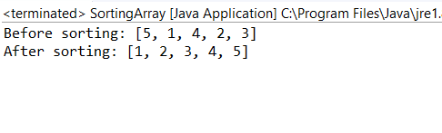

QUE 5:- Write a java program to replace the second element of an ArrayList with the specified element.

INPUT:-

**package** Collection;

**import** java.util.*;

**public** **class** ReplacingElement {

**public** **static** **void** main(String[] args) {

// **TODO** Auto-generated method stub

//creating the LinkedList object

LinkedList<String>a=**new** LinkedList<String>();

//adding elements in list

a.add("aditi");

a.add("anjali");

a.add("karishma");

//printing the all elements

System.***out***.println("All elements in the list: "+a);

//replacing the elements

a.set(1, "sakshi");

//printing the replacing elements

System.***out***.println("new list: "+a);

}

}

OUTPUT:-

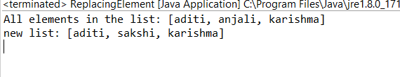

QUE 6:- Write a java program to iterate a linked list in reverse order.

INPUT:- **package** Collection;

**import** java.util.*;

**import** java.util.Collections;

**public** **class** LinkedListReverseDemo {

**public** **static** **void** main(String[] args) {

// **TODO** Auto-generated method stub

//creating the object of the LinkedList

LinkedList<String>list=**new** LinkedList<String>();

//importing the elements in the list

list.add("aditi");

list.add("sakshi");

list.add("karishma");

list.add("kajal");

list.add("anjali");

//printing the original elements in the list

Collections.*sort*(list);

System.***out***.println("the sorted list: "+list);

//implementing the logic for reversing the elements

Collections.*sort*(list,Collections.*reverseOrder*());

System.***out***.println("the reverse form of the list: "+list);

}

}

OUTPUT:-

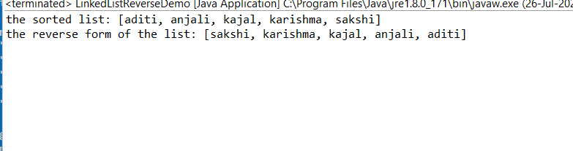

QUE 7:- Write a java program to retrieve, but not remove the last element of a LinkedList

INPUT:-

**package Collection;**

**import java.util.*;**

**public class RetrivingElement {**

**public static void main(String[] args) {**

**// TODO Auto-generated method stub**

**//creating the object object of the linked list**

**LinkedList<String>a=new LinkedList<String>();**

**//importing the element in the list**

**a.add("aditi");**

**a.add("sakshi");**

**a.add("karishma");**

**a.add("kajal");**

**//printing the values in the list**

**System.*out*.println("the last element is: "+a);**

**}**

**}**

OUTPUT:-

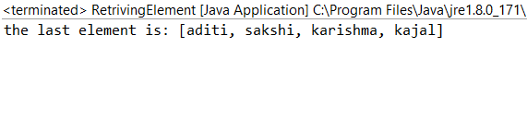

QUE 8:-Write a java program to create a LinkedList of integers and print all the elements.

INPUT:-

**package** Collection;

**import** java.util.*;

**public** **class** LinkedListInteger {

**public** **static** **void** main(String[] args) {

// **TODO** Auto-generated method stub

//Creating the object of linked list

LinkedList<Integer>a=**new** LinkedList<Integer>();

//importing the element

a.add(1);

a.add(5);

a.add(6);

a.add(9);

a.add(3);

//printing the elements

System.***out***.println("the integer numbers in the list are: "+a);

}

}

OUTPUT:-

